**TATA CUMMINS LTD  
JAMSHEDPUR, INDIA**

**AT**

**SUMMER TRANING -2021**

**PROJECT REPORT**

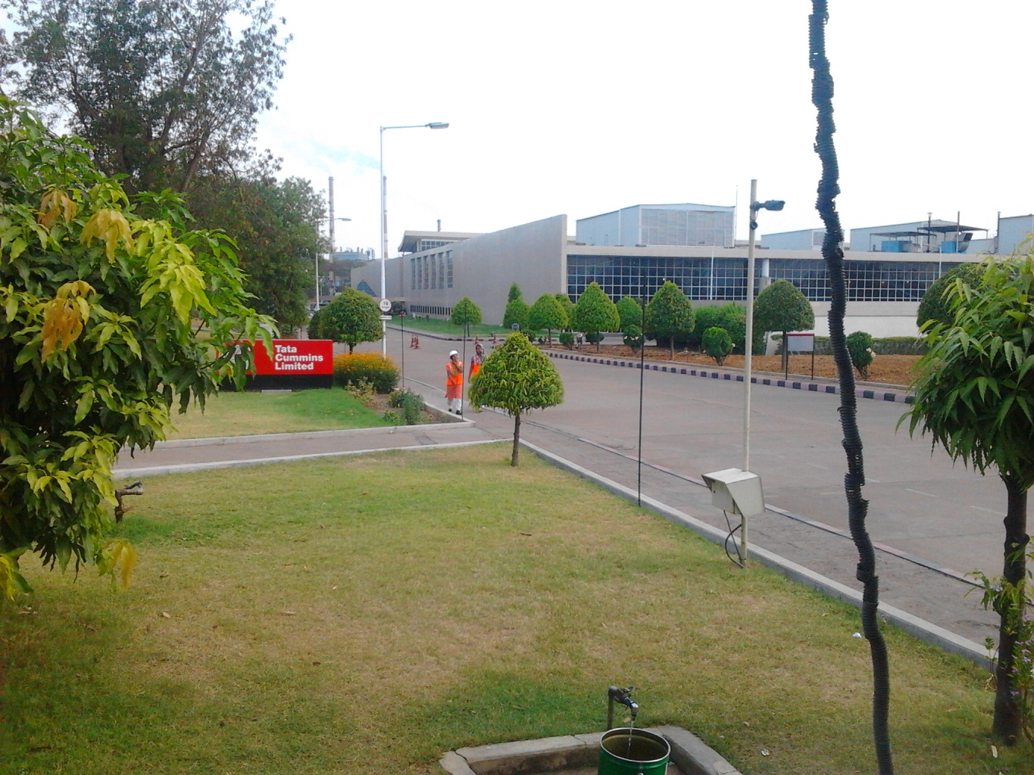

**SUBMITED BY**

**ABHISHEK LAL**

**MECHANICAL ENGG 5TH SEM**

**BEHARAGORA POLYTECNIC**

**PROJECT GUIDE :**

**PK SANTHOSH**

**OPERATIONS LEADER-**

**FORGING MACHINING**

**PROJECT**

* To study the machining process of connecting rod and cam shaft and prepare the chemical safety data sheet of chemicals used in Connecting Rod and Camshaft line.

**CONNECTING ROD**

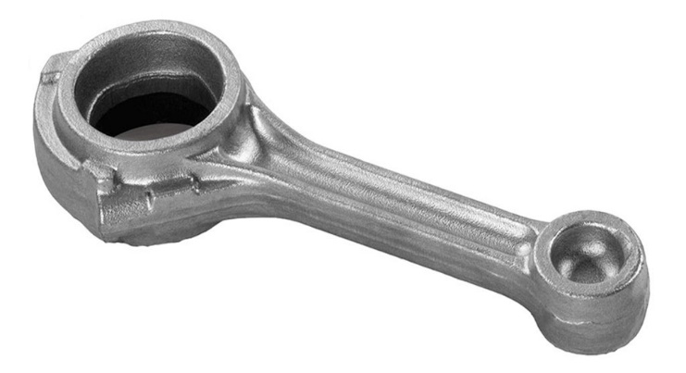

**CAMSHAFT**

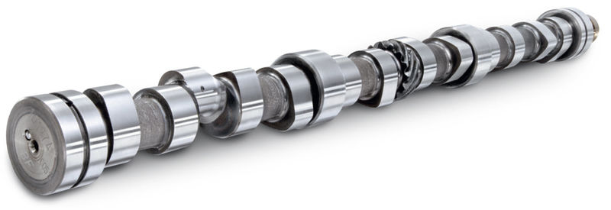

PREFACE

This report is a sincere effort to reveal the expression of my experience, observation and study apart from my regular academic curriculum. This industrial training at TATA CUMMINS Ltd. Jamshedpur in the Department of RCBU was the real experience that has helped me to gain practical knowledge of engineering and lear the discipline and safety of working in industries.

I was mainly focused on the study of machining operation and preparation of **chemical safety data** **sheet** for all machines in the Conrod and Camshaft line. I made an overview of the standardized work sheet for (RCBU) after enhancing my knowledge about machining of a conrod and camshaft.

***Acknowledgement: -***

It gives us an immense pleasure to present the report of the project undertaking by me during summer training. We owe special debt of gratitude to Mr P.K. Santhosh and Mrs Sanju Kumari (HR. DEPT.) at TATA CUMMINS PVT.LTD. Jamshedpur for their constant support and guidance throughout the course of my work. Their sincerity, thoroughness and perseverance have been a constant source of inspiration for us. It is only his cognizant efforts that our endeavours have seen light of the day.

We also take the opportunity to acknowledge the contribution of all the staff members at TATA CUMMINS PVT.LTD. For their full support and assistance during the development of the project.

CERTIFICATE

To whom it may concern

This is to certify that Abhishek Lal, student of “**Beharagora Polytechnic Collage”** has undergone a summer Training at TATA CUMMINS Ltd during the period 8-09-2021 to 8-10-2021. During this training he has successfully completed a project on “**Study of machining operations of a Connecting Rod or Camshaft and preparation of chemical safety data sheet** under my supervision.

**PK Santhosh**

**Operation leader- Forging Machining**

**CONTENTS**

**1.INTRODUCTION OF TCPL**

**2.SAFETY MEASURES FOLLOWED IN TCPL**

**3.COMPONENTS BEING PRODUCED IN TCL**

**4.PROJECT DETAILS**

**4.1. PURPOSE**

**4.2. CONNECTING ROD(INTRODUCTION)**

**4.3. EXPORT and DOMESTIC LINE:**

**PROCESS FLOW OF CONNECTING ROD**

**4.4. CAMSHAFT(INTRODUCTION)**

**4.5. PROCESS FLOW CHAT OF CAMSHAFT**

**4.6. Organizational Tree/Structure of Forging line**

**5. CHEMICAL USED IN CONNECTING ROD**

**& CAMSHAFT LINE**

**5.1. CHEMICAL SAFTY DATA SHEET-HYSOL G 100**

**5.2. CHEMICAL SAFETY DATA SHEET-HONILO 961**

**6. LEARNING**

**7. REFERENCE**

**1.INRODUCTION OF TCPL**

**Cummins Engine Company Inc**. was founded in Columbus, Indiana in 1919 when successful banker/investor W G Irwin supplied the capital for a local self-taught mechanic and inventor Clessie Cummins to begin manufacturing diesel engines. Working out of an old cereal mill in Columbus, the first engine made by Cummins was a Dutch designed, six horsepower, farm type diesel. By 1925, the company had begun producing its own design with enough success that operations were relocated to a new larger site where the Columbus Engine Plant is now located. It was here that Cummins created the breakthroughs that solved critical problems of injection timing and introduced a successful marine engine, originally installed in shrimp boats. The engine proved so economical that its popularity soon spread to other applications, including generator sets, drills, power shovels and air compressors.

Cummins has been associated with the Indian subcontinent for five decades. The stage was set way back in 1962, when a partnership between Kirloskar and Cummins crystallized into a 100-acre manufacturing campus in Pune. Within a span of three years from commencing operations, the business venture started to generate profits. Thereon, the partnership continued to flourish, till up till 1997, when the Kirloskar’s sold their ownership; resulting in Cummins Inc. increasing its stake to 51% and the rest being traded on the Bombay Stock Exchange. This led to the formation of Cummins India Limited, a consolidated subsidiary of Cummins Inc

**Tata Cummins** is a joint venture between these two world leaders. The agreement was signed in July 1993 with plant construction starting in the industrial township of Jharkhand-Jamshedpur in April 1994 and commercial production commenced on January 1 1996. The entire organization has been set up from scratch at a Greenfield site. The Rs 300 croreproject widely acknowledged to be the fastest implementation of its size and nature (within budget) in the industry and within Cummins family worldwide. The Company has installed capacity to manufacture 1,20,000 Engines. Tata Cummins Pvt Limited is a 50:50 joint venture between Tata Motors Limited, India's largest automobile manufacturer and Cummins Inc., USA

Our Product: Engines for

Automotive

* Buses
* Trucks
* Tippers
* Defense

Non-Automotive

* Marine
* Genset
* Construction
* Compressor

**2**. **SAFETY MEASURES FOLLOWED IN TCL: -**

* An area marked by black lines throughout the corridor serves the footpath for people walking.
* Use of convex mirrors at blind curves to make people aware of any moving body coming from another side (forklifts in the worst case).
* Use of warning signboards at regular places directing how to be safe in the plant.
* Safety shoes are the must to be worn inside the plant while working or moving.
* Use of safety gloves as per PPE Matrix / Standard Work Method is necessary while working on the machines or coming in physical touch with the machines /Components.
* Safety glasses are a must to be worn by people working or roaming through the plant.
* Use of ‘LOTO’ i.e. Lock Out Tag Out which means to lock out the machines during maintenance or other job different from everyday use.

**3.Components being produced in TCL: -**

Shop Operations is the core function of the company which manages the complete operations in the shop. It holds almost 70% of total company’s manpower

Shop Operations consists of

* Assembly, Test and paint BU (ATP)
* Cylinder Block BU (CBBU)
* Cylinder Head BU (CHBU)
* Crank Shaft BU (CRBU)
* Connecting Rod and Cam shaft BU (RCBU)
* Tool Room
* In 1995 Assembly started with a capacity of 60, 000 engines / annum. With Capacity expansion in 2007 capacity increased to 1, 20, 000 engines. It has the capability to build Euro-1, 2 & 3 to Euro 6 engines (Both Mechanical and Electronic versions).
* Cylinder Block and Cylinder Head lines had their expansions completed in 2008 and acquired the capability to manufacture Euro 6 Blocks and Heads in 2008 which takes their capacity to

1, 20, 000.

* Crank shaft line is also having capability to produce BS 4 crank shaft with capacity of 48,000 per annum.
* Connecting rod has the capability to produce BS 6 and capacity of 60,000 Sets per annum.
* Cam shaft line is also having capability to produce up to BS 4 cam shaft with capacity of 72,000 per annum.
* Tool room provides all the tooling, Wear parts support to Business Units. It has tool grinding and presetting facilities. It also provides support for maintenance jobs.

**4. PROJECT DETAILS**

I have done my project in RCBU. In my project I prepared the Chemical Safety Data Sheet for the different machines in Connecting Rod and Cam Shaft line. In RCBU various machines are present whose work method is to be standardized and presented. This is the essence of the above.

* **4.1. Purpose**

Purpose of my project is to study the machining operations and to prepare the Chemical Safety Data Sheet for various machines operating in Conrod and Camshaft (RCBU) to make the working efficient and standardized.

* **4.2. Connecting Rod (Introduction)**

A **connecting rod** is the part of a [piston engine](https://en.wikipedia.org/wiki/Reciprocating_engine) which connects the [piston](https://en.wikipedia.org/wiki/Piston) to the [crankshaft](https://en.wikipedia.org/wiki/Crankshaft). Together with the [crank](https://en.wikipedia.org/wiki/Crank_(mechanism)), the connecting rod converts the [reciprocating motion](https://en.wikipedia.org/wiki/Reciprocating_motion) of the piston into the rotation of the crankshaft. The connecting rod is required to transmit the compressive and tensile forces from the piston. In its most common form, in an [internal combustion engine](https://en.wikipedia.org/wiki/Internal_combustion_engine), it allows pivoting on the piston end and rotation on the shaft end.

The predecessor to the connecting rod is a mechanic linkage used by water mills to convert rotating motion of the water wheel into reciprocating motion.

The most common usage of connecting rods is in [internal combustion engines](https://en.wikipedia.org/wiki/Internal_combustion_engine) or on [steam engines](https://en.wikipedia.org/wiki/Steam_engine)

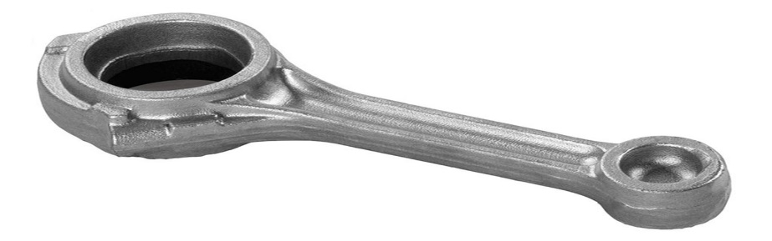

**4.3. Export and Domestic Line: process Flow of Connecting Rod**

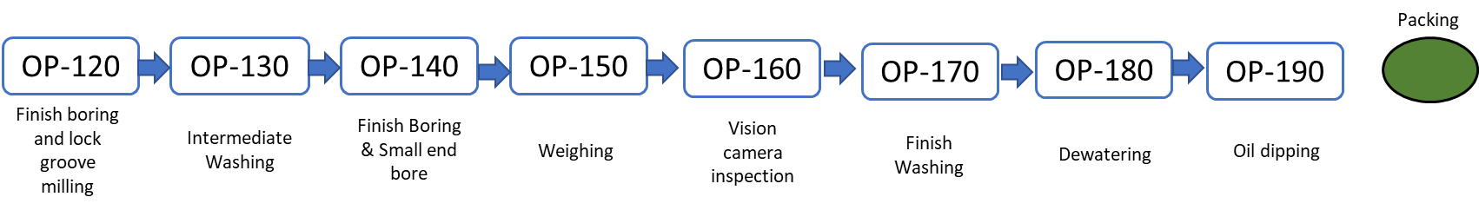

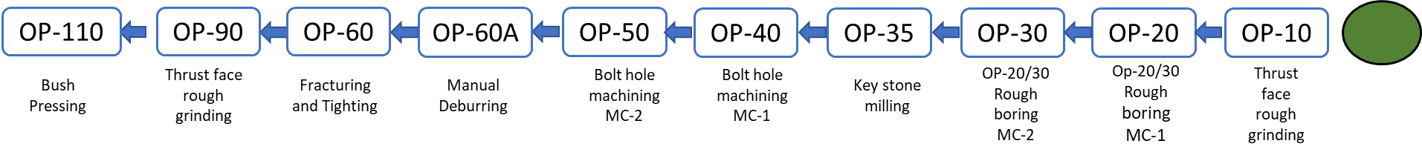

**4.4. Camshaft (Introduction)**

A camshaft is a rod which rotates and slides against a piece of machinery in order to turn rotational motion into linear motion. This change of motion is accomplished by the camshaft moving further and closer from the axis of rotation as the camshaft is pushed by the machinery. These moving pieces of the shaft are the [cams](https://energyeducation.ca/encyclopedia/Cam).

A camshaft on an [internal combustion](https://energyeducation.ca/encyclopedia/Internal_combustion_engine) [heat engine](https://energyeducation.ca/encyclopedia/Heat_engine) is a device that controls both the input of fuel and the expulsion of exhaust fumes. It consists of several radial cams, each displacing intake or exhaust valves. This camshaft is connected the [crankshaft](https://energyeducation.ca/encyclopedia/Crankshaft) via belt, chain or gears. This ensures consistent timing of the valves in relation to the motion of the pistons



**4.5. PROCESS FLOW OF CAMSHAFT**

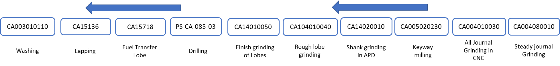

**4.6. Organizational Tree/Structure of Forging line**

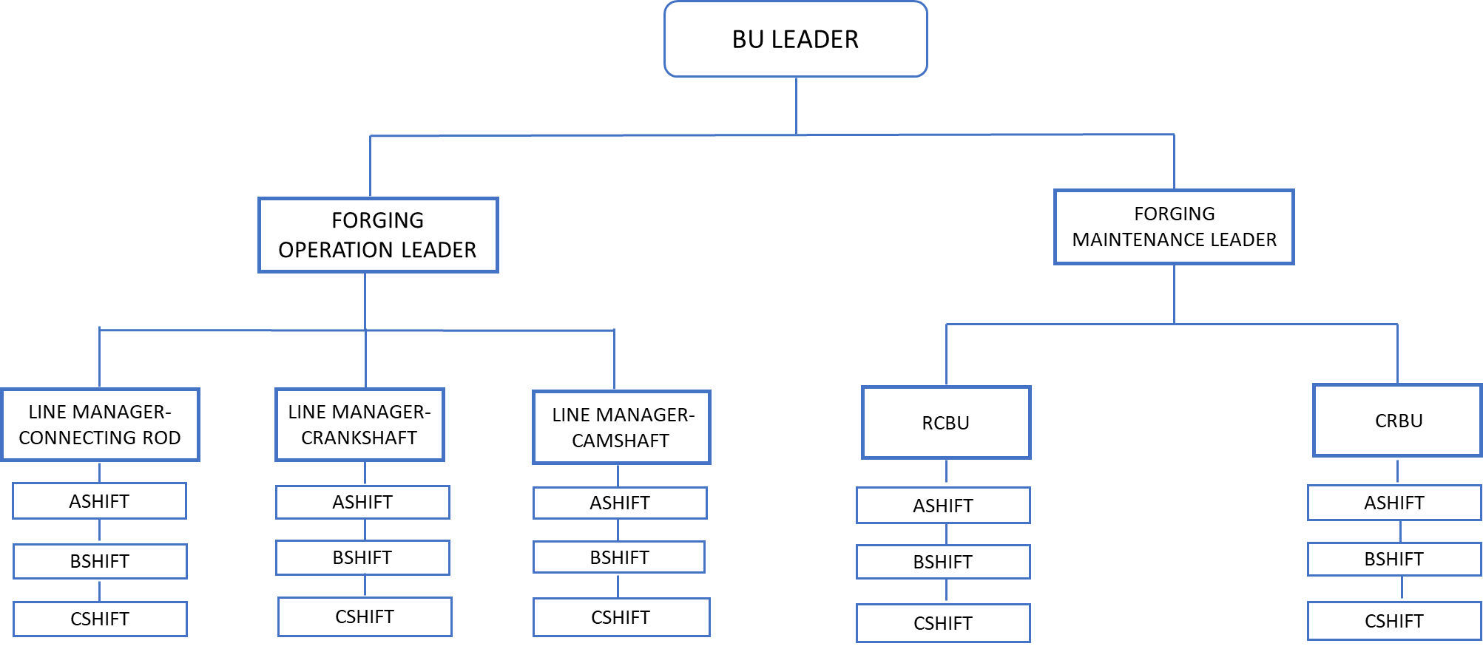

**5. CHEMICALS USED IN CONNECTING ROD &CAMSAFT LINE**



**5.1.Chemical Safety Data Sheet-HYGOL G 100**



**5.2.Chemical Safety Data Sheet -HONILO 961**



**LEARNING**

After commencing the training from Tata Cummins Ltd. I got a clear and firm idea about the machining operations being held. I also gained knowledge about importance of time in an industry. The motion and pace of the machining operations is also a part which is to be focused and emphasized upon. I also got an idea about making the operations and chemical work sheet so as to achieve better results and to attain a higher production rate.

**References:-**

* Process document of Connecting Rod & Camshaft

line.

* Standard work sheet of other lines.
* Process document of machines.
* Pdf document downloaded from internet.